# Project Design Phase-II Technology Stack (Architecture & Stack)

|  |  |
| --- | --- |
| Date | 18 October 2022 |
| Team ID | PNT2022TMID38914 |
| Project Name | News Tracker Application |
| Maximum Marks | 4 Marks |

**Technical Architecture:**

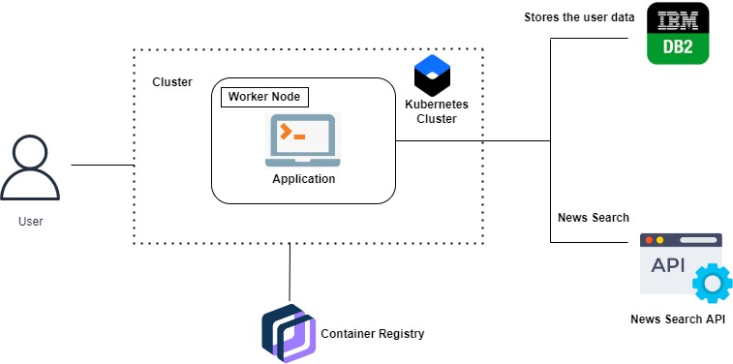

# Table 1: Components & Technologies:

|  |  |  |  |
| --- | --- | --- | --- |
| **S.No** | **Component** | **Description** | **Technology** |
| 1. | User Interface | The user can interact with the application to know about the trending news | HTML,CSS,  JavaScript/  Angular Js/ React Js etc. |
| 2. | Application  Logic-1 | The application contains this resource gives  you basic understanding of Flask | Flask |
| 3. | Application Logic-2 | The application contains the news sub-  division like geographical news, economic news and society news | IBM Watson STT service |
| 4. | Application  Logic-3 | The user can view the growth of the  economy in industry through graph | IBM Watson  Assistant |
| 5. | Database | Updation of trending news are stored in the  MySQL database | MySQL, NoSQL,  etc. |
| 6. | Cloud  Database | With the use of cloud, media coverage issue  cannot be occurred | IBM DB2, IBM  Cloudant etc. |

**Table 2: Application Characteristics:**

|  |  |  |  |
| --- | --- | --- | --- |
| **S.No** | **Characteristics** | **Description** | **Technology** |
| 1. | Open-Source Frameworks | Flask is flexible and doesn’t require to use any particular project or code  layout used in this application | Python-Flask |
| 2. | Security  Implementations | This can be access only by the  journalist. So, It is a high Security | Container Registry,  Kubernetes Cluster. |
| 3. | Scalable Architecture | News Tracker is a socio-economic access because helps to know about  the daily activity of the world | Container Registry, Kubernetes Cluster. |
| 4. | Availability | This application will be available to  the all the user who are using this application | Container Registry, Kubernetes Cluster. |
| 5. | Performance | The updation of trending news occurs without any interruption. So,  it performance is good | Kubernetes Cluster. |

# References:

<https://github.com/IBM-EPBL/Assignments-CApD/tree/main> <https://ieeexplore.ieee.org/document/5616930> <https://ieeexplore.ieee.org/document/1565880> <https://ieeexplore.ieee.org/document/8703401>